OO Programming Fundamentals

Practical Week 7 – 3rd November 2014

Create a Practical Week folder in your Java folder on your G drive

G:\Java\Practical Week 7

- Save all the following exercises into the Practical 7 folder

Exercise 1:

Write a program which accepts 5 numbers from the user – this time using a while loop. The program should add the 5 numbers and display the total. Also, display the average of the numbers.

Create project in Practical Week 7 folder as: ex7a
Sample Output
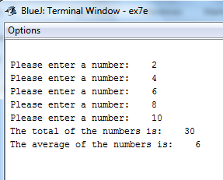

Exercise 2:

Write a program using an if statement and while loops to ask the user to enter a number (positive or negative) and then counts from 0 to that number.

Create project in Practical Week 7 folder as: ex7b
Sample Output
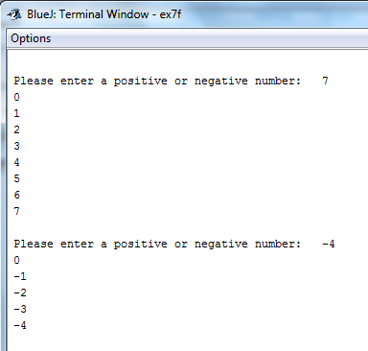

Exercise 3:
Write a program that asks the user to enter in their age. Using a while loop ensure that they can only enter in positive values and if they enter a negative number the loop must allow them to enter a value for age again.
The program must then calculate and display to the screen how old they will be on their next birthday.

Create project in Practical Week 7 folder as: ex7c
Sample Output
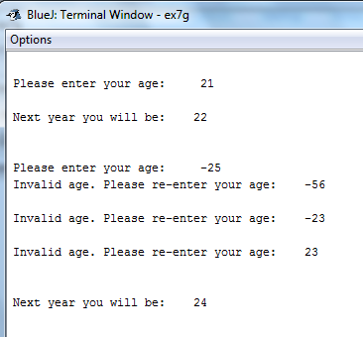

Exercise 4:

(From Lecture Notes on Repetition – Do While Loops) Write a program that will ask the user with to enter in all the students in a course. You must ask for their name, student number and year of course. You must then present this information on the screen before asking them to enter in another record. When there are no more students on the course. Tell them thank you for entering the details.
Use a Do..While loop

Create project in Practical Week 7 folder as: ex7d
Sample Output

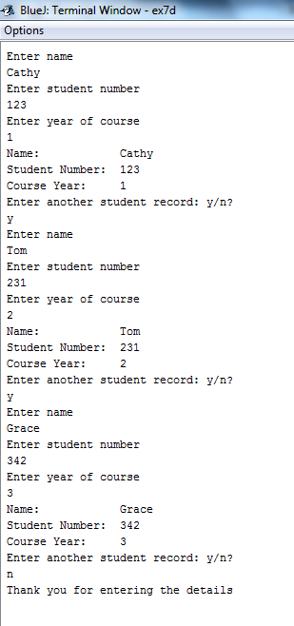

Exercise 5:
Write a program to do the following:
  - Ask the user to enter a number
  - Take the number from the user and store in a variable
  - If the number is less than 10 print "Less than 10" to the screen 7 times
  - If the number is greater than 10 print to the screen "Greater than 10" to the screen 4 times
  - The program should then ask the user if they would like to enter another number y/n.
  - If the user enters y or Y then the user should be asked to enter a number, take in the number and store it in a variable, check if it's less than or greater than 10 and print a corresponding message to the screen (as above).

Create project in Practical Week 7 folder as: ex7e
Sample Output

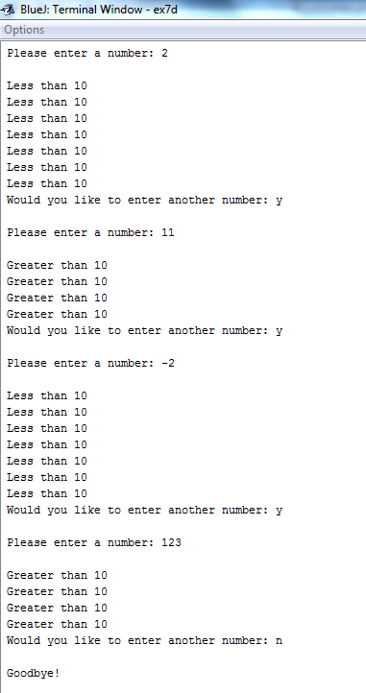

Exercise 6:
Present the user with the following options as a menu:
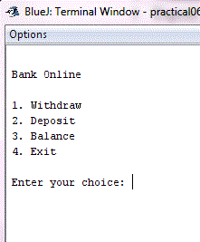

- Assign the users an initial bank balance of 100 euro.
- Ask the user to enter one of the menu choices (1, 2, 3, or 4)
- If the user chooses 1 you must :
  - Ask them how much they want to withdraw from their account and
  - Calculate and display their new balance.
- If the user chooses 2 you must:
  - Ask them how much they want to deposit and
  - Calculate and display their new balance.
- If the user chooses 3 you must display their balance to the screen.
- If the user chooses 4 you will say goodbye and exit the program.
- This program will continue to show the user the options until they want to exit.

Create project in Practical Week 7 folder as: ex7f

Sample Output
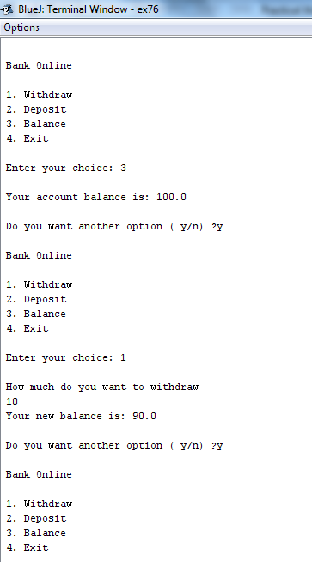
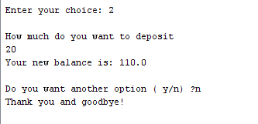

Exercise 7:

Take the code from the previous program and rewrite it, using a new class, to do the following:
- Assign the users an initial bank balance of 100 euro.
- Present the user with the following options as a menu:
  - Ask the user to enter one of the menu choices (1, 2, 3, 4 or 5)
    - If the user chooses 1 you must ask them how much they want to withdraw from their account and calculate and display their new balance.
    - If the user chooses 2 you must ask them how much they want to deposit and calculate and display their new balance.
    - If the user chooses 3 you must display their balance to the screen.
    - If the user chooses 4 you must show them how many times they checked their balance, how many deposits they made and how many withdrawals they had.
    - If the user chooses 5 you will say goodbye and exit the program.
- This program will continue to show the user the options until they want to exit.

Create project in Practical Week 7 folder as: ex7g

Sample Output

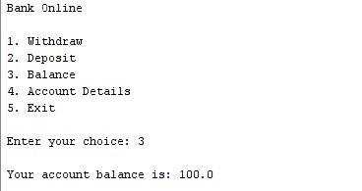
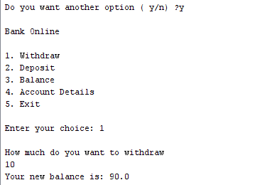

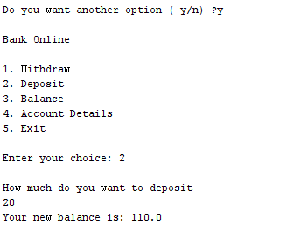
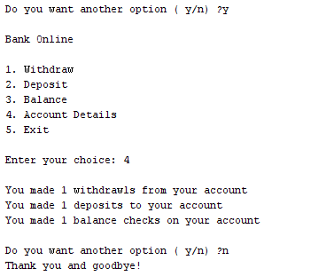

Completing this week's Practical:
- When you submit work, you will send it in zip file format.
- To create a zip file of your practical work:
  - In Windows Explorer, right click on the Practical Week 7 folder that contains your work.
  - When the context menu appears, choose the Send to option, followed by the Compressed (zipped) folder.
  - This will create a new file called Practical Week 7.zip in your current folder
- Note: If you are using your own laptop, you can choose to install very good (and free) compression software called 7zip. Just search for it in Google and download it.

*** It is this zipped file that you will upload into Moodle.***

